2020-21 WIDA ACCESS GUIDELINES & PROCEDURES

EL Test Coordinators & Administrators
EL Test Coordinators (TC) and Administrators (TA’s) are responsible for:
- Sign/agree to the Non-disclosure and User Agreement (NDUA)
- Working with Technology Coordinator to ensure the COS is set up and INSIGHT Secure Browsers are on all Testing hardware
- Completing WIDA administration training at State (TC) /School (TA), and complete the online ACCESS Certification Course and pass with 80% accuracy
- Review State EL Checklist
- TC/TA ensure that correct and complete information is either labeled or bubbled in each
student booklet and K and 1-3 writing booklets are kept in a secure area when not in use
- All student accommodations and administrative considerations are set in ECSSS and in the WIDA AMS (for Accommodations) See spreadsheet
- Assuring the test environment meets the specified COVID requirements
- Administering the WIDA ACCESS ensure students have ample time to use the practice, going through the Test Demo, Sample Items and Test Practice found in WIDAAMS
- Assessments are to be administered at a secure testing site such as a school computer lab, library, or classroom.
- Students who are distance learning are required to be assessed in-person and school-level staff are expected to communicate the requirement to the parents/guardians of distance learning students and address concerns to ensure needs are met.
- Reporting all potential test security incidents to the EL Test Coordinator

EL PTTs may administer the ACCESS for ELLs if the following conditions are met:
- Has a Bachelor's degree that has been completed at a regionally accredited institution of higher education.
- Hired by the school to work with EL population; AND
- Has completed required ACCESS for ELLs training, applicable checklists, and passed the online quiz(es) with 80% (Speaking, Writing, Alternate ACCESS for ELLs, and/or Kindergarten ACCESS for ELLs, as applicable).

Proctors
Proctors are provided to support Test Administrators and may NOT administer any of the online assessments and do not need to take the online TA Certification Course.

EL staff (i.e. PPEs, PPTs, and Educational Assistants) may only serve as Proctors under the direct supervision and in close proximity of a WIDA certificated regular classroom teacher. Proctors must be supervised by a Test Administrator at all times.

They are not required to remain in your class the entire testing period, but are provided to support Test Administrators especially at the start and end of each testing session.

Proctors may:
- Walk around the room to monitor students’ behavior
- Inform the Test Administrator if anyone becomes ill, is disruptive, or appears to be cheating
- Assist Test Administrator with distribution of test materials, prepare computers, etc.

Testing Rooms
- Information displayed on bulletin boards, whiteboards, or charts that students might use to help answer test items MUST BE REMOVED OR COVERED. This applies to rubrics, vocabulary charts, student work, posters, graphs, charts, etc.
- During testing, place “DO NOT DISTURB Testing In Session” signs on door
- During testing, keep doors closed but unlocked

WDIA ACCESS Testing Folders
- WIDA ACCESS Packets will be provided to each EL Test Administrator by the Test Coordinator at the face-to-face meeting.
- Testing Packet Contents:
  - WIDA Calendar
  - WIDA Modified Schedule
  - Copy of the Test Administration Manual (TAM) includes Directions for Administration
  - Copy of the script
  - Scratch Paper
  - WIDA ACCESS Guidelines and Procedures
  - Pencils (please return after testing)
  - Test Session Ticket Info/Roster/Test Tickets
  - Testing Incident Report Form
  - DO NOT DISTURB Signs (2)

Cell Phones/Electronic Devices/Watches
- At the beginning of the test session, instruct students to TURN OFF and place all cell phones, electronic devices, and WATCHES in their bags.
- Instruct students to only take out their headphones or use the ones provided.
- Ask students to place their bags in a designated, secure area in the classroom that cannot be accessed during the test session.

Test Problems
- Inform your proctor and they will contact the Test Coordinator
- Call the office at ### or ### and office will contact the Test Coordinator
- Either Test Coordinator or VP/Principal will come to your room ASAP

Tardy Student
- Tardy students will be allowed to enter the test environment as long as there is ample time to test, keeping in mind the length of the testing period (school-based decision).
- Please have all computers ready for your class. For example, if your Period 1 class has 25 students, have 25 computers ready to go with the secure browser on the screen.

Inappropriate Behavior/Sick Students
- Phone the office at extension ### or ### and student must wait until a staff member comes to your classroom to pick up student
- Complete the Testing Incident Report Form that is placed in your testing folders

Quiet Work
- When a student completes testing during the testing session, they must turn off the computer and can only engage in “QUIET WORK”
- “QUIET WORK” includes the following:
  - Scribbling or drawing on a blank scratch paper which needs to be collected at the end of the test session and shredded
  - Sudoku puzzles, seek a word, coloring intricate color books
  - They can read a book but not anything to do with classroom work.
- NO academic/content homework completion allowed which includes surfing the internet or subject curriculum books, after testing in the testing environment, even if it does not contain the content being tested.

Testing Times
Approximate times to each domain are as follows and may differ based on school schedules:
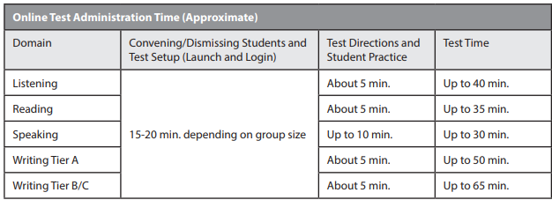
- Each domain must be given in one sitting and cannot be separated across multiple days or times during a single day, unless in the case of emergency.

Pausing Test
Students who do not finish the test during the time provided must click [PAUSE] when directed to do so.
- A countdown beginning with 30 minutes appears on the screen notifying the student of the time left before the system automatically exits the test.
- To resume the test within 30 minutes of pausing, instruct the student to click the Resume button. The student will be taken to the screen they were on when they clicked to pause the test. If the test was on a screen that had audio, the audio will restart from the beginning.
- If the test is paused for more than 30 minutes, or if there is no mouse or keyboard activity for more than 30 minutes, the INSIGHT test system will automatically exit the test. The student must log back in to finish the test, which will start up again on the screen at which the test was exited.
- If the student needs to leave the testing room for more than 30 minutes, click the Exit Test button.
- Students will not be able to review or change the answers they have already worked on when the test is paused.

Make-Up Testing
- Students who are absent from the testing period will need to be placed in make-up sessions

Procedures Prior to Administration

- The number of students in test session may vary but students must be at least 6 feet apart with masks, 12 feet apart if not wearing mask (i.e. speaking test)
- Each student have their own 3' x 6' table or desk
- All of their belongings placed under their table only
- Temperature taken before they enter the room
- Everyone wears a mask at all times (Depending upon school policy, masks might be removed for the speaking test in distances between students is increased)
- Use gloves to distribute and collect the tests
- Students not allowed on campus more than 30 minutes before their test and must leave immediately after testing*
- Allow at least 30 minutes between each group for tables, chairs, handles, headsets, keyboards, mice and anything else that a student may have touched to be sanitized*
- Stagger their location and times
- Students do not cross paths in stairwells or bathrooms *
- At the end of the day, clean bathrooms and floors, teachers wipe all the areas again.*
*Subject to school policies and procedures

DAY OF TEST ADMINISTRATION

STUDENT COMPUTERS
- Before students arrive to take an assessment, make sure that the student login screen is showing on each computer and have a headset with a mic available and checked for sound.
- Make sure all students have their own test tickets.
- Click on the INSIGHT Secure Browser(desktop) or INSIGHT (apps-- chromebook) on each computer to open the secure browser.
- It is recommended that Test Administrators rather than students launch the browsers in order to prevent students from accessing other applications.
- Once a student is done with the test and using a Chromebook please be sure to plug the computer back in the mobile lab cart.
------------------------------------------------------------------------------------------------------------------------------
It is necessary to administer the Listening and Reading tests first because a student’s tier placement for Writing and Speaking is determined by his or her performance on the Listening and Reading tests.
-------------------------------------------------------------------------------------------------------------------------------
Listening Test
Above the picture, students will see a character or characters. The character(s) will explain the content of the passage. After listening to the passage, students will select a response option from the set of multiple-choice questions on the screen. The test engine will then digitally capture and score students’ responses. A benefit of the online format is that it will allow students to progress through the Listening test using the next button at their own pace.

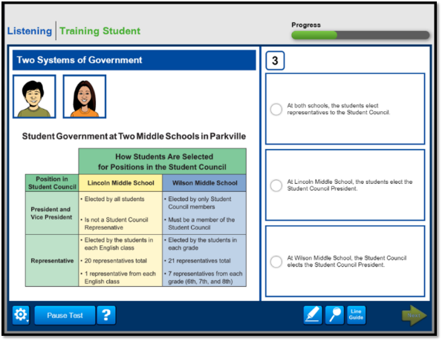

-------------------------------------------------------------------------------------------------------------------------------Reading Test
Above the picture, students will read the directions and then read a short passage appropriate to the grade and proficiency level. Next, students will read the question and select the appropriate answer from a set of multiple-choice questions. The test engine will then capture and score students’ responses. As with the Listening test items, the online test will allow students to read the items and progress through the Reading Test using the next button at their own pace.

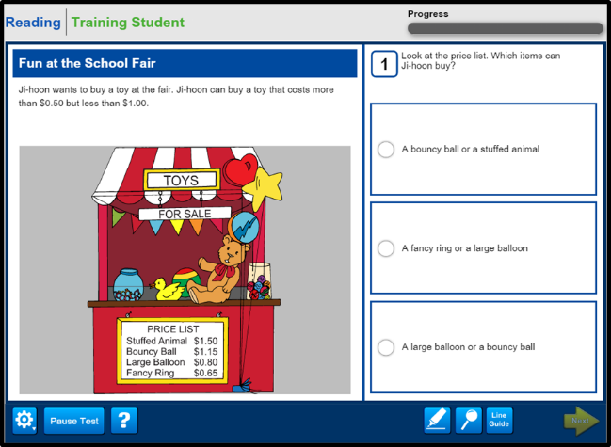

------------------------------------------------------------------------------------------------------------------------------
Speaking Test
In the center, students will see a picture. To the left, they will see a virtual test administrator and a model student. The virtual test administrator will guide the student through the Speaking passages with directions and prompts. Next to the virtual test administrator, students will see a model student. The role of the model student is to provide examples of expected responses. As shown on this slide, the virtual test administrator will first ask a question to the model student.

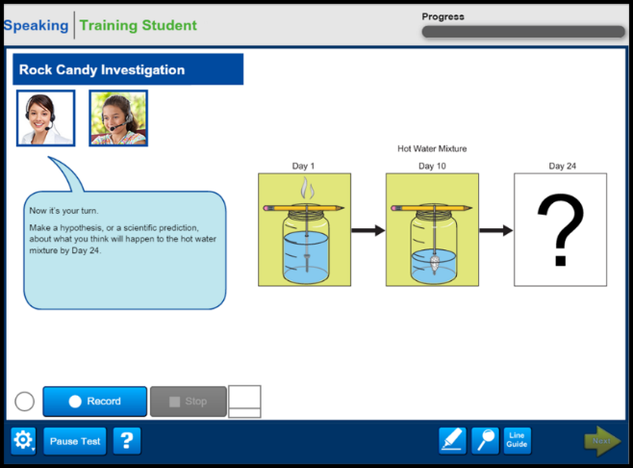

-------------------------------------------------------------------------------------------------------------------------------
Writing Test
On the computer screen, students will see a picture and read text that models the type of answer that is expected. Students will also hear an audio prompt and read the directions. In the text box, they will enter their response using the keyboard, depending on their grade and proficiency level. The directions will emphasize that students are to create their own answers in the text box. The test engine will then save the students’ responses and automatically send them to DRC for scoring.

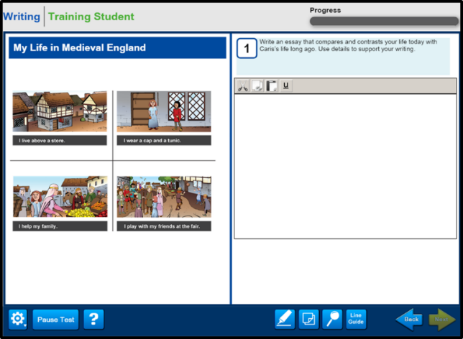

-------------------------------------------------------------------------------------------------------------------------------

IF YOU HAVE ANY QUESTIONS OR CONCERNS, PLEASE CONTACT YOUR RT

Good luck and Happy Testing!

